Rhiannon Foster

Website Development

Table of Contents

Web Architecture 2

Web components 3

Web Functionality 4

Role of Web Architectures in Website Communications 4

Current method of information sharing 5

References 6

# Web Architecture

Without the correct set up you will not be able to use the internet as you will not be able to connect to servers and therefore will be unable to respond to requests. To do this, you do need to include:

* **Internet Service Protocol (ISP) –** this is a method which sends data from one computer to another on the internet. Every computer has a different IP address and the internet protocol delivers them.
* **Web Hosting Services –** This is a service where the provider allocates space on a web server to store files, this is a website that they will be hosting. The files then compromise the website available for viewing online. Every website is hosted on a server.
* **Domain Structure –** domain structure is how the web address is set up. You can split the web address into the protocol and the domain name. for example : https://[www.google.co.uk](http://www.google.co.uk), the https:// is the protocol and the .google.co.uk is the domain name. this allows the browser to determine what type of page it is.
* **Domain name registrars -** this is the company that sell the domain names. The registrars send the name to the costumer and then the registrar is responsible for keeping records of owner’s information relating to the name. the name needs to be submitted and the user can display their information using the ‘WHOIS’ tool.
* **World wide web –** this is the information that is due to the internet. The WWW documents can be linked using HTML.

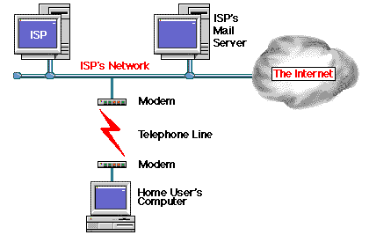

How the ISP works

# Web components

You need components in order for the internet to work and serve the content, some components are:

* **Hardware** 
  + **Web Server –** to visit a website the user’s device will send a request to the web server that is hosting the website. The server will then send the information that client will need to display the content of the website.
  + **Mail Server –** this server is dedicated to transferring mail across the internet. As the user, you will be able to logon to your emails which are stored on a server and therefore can access them wherever you are. This
  + **Proxy Server –** this is a special type of server that acts as a middleman in-between the client and internet. Companies use this server to filter what the employees can access. You can also use this server to change the IP address of your device.
* **Routers -**  a router is a device that makes sure your data packets are downloaded from the internet and are on the correct device, this means that a router is needed if there is more than one computer or device on a network. Routers can also send data packets along the routes needed to get to the destination.
* **Software**
  + **Browser –** this is used by internet users. The browser works by sending requests to the web server for the files it needs to access. It will wait until the files are sent back and then will display. It interprets the HTML and CSS code.
  + **Email Client –** this is for the user to connect to the mail server from their device, this allows them to then access their emails and will be sent when the connection is refreshed.
* **Protocols –** this is how a pair of computers can communicate with each other about packet sizes and error checking etc.
  + **Transporting and Addressing (TCP/IP) –** this protocol is used to transport data around the internet and makes sure the packets end up at the correct address.
  + **Applicant layer (HTTP, HTTPS, SMTP) –** there are different types of protocol that are used to interact with the client. HTTP is for a standard webpage, HTTPS is for secure webpages and SMTP is for mail.

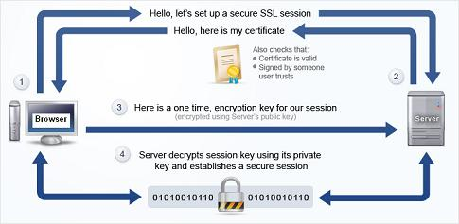

# Web Functionality

* **Web 2.0 –** web 2.0 is another version of the original world wide web. It has been changed so that you can use it dynamically or user generated which means that it is always growing due to the users. An example of this is google, google relies on popularity to be successful. That means that they need to provide the user with reliable information fast and easily so that anyone can use it.

# Role of Web Architectures in Website Communications

Without the architecture of the internet, there wouldn’t be an internet but how does it work? To access a web site, the client will need to enter a web address in the browsers address bar. The browser sends a request to a DNS server with the information of what web page is associated with the web address and this is either stored in cache or in the server’s database. When the server has found the correct information then it will send it back to the user but if there is nothing on the records then it will be passed onto another server and so on. Once there is a match it will be sent to the original DNS server and then to the user. Once the users computer has the correct information it needs it will then send a request to get the files it needs to show the user the web page. The server then dents the files that the user is using.

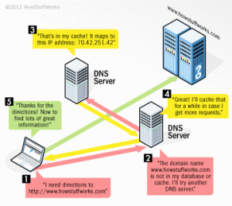

# Current method of information sharing

The current method is information sharing is the principle of web 2.0. This means that information can be changed by many people. Web 2.0 has brough us dynamic web pages which can be updated easily by lots of people using databases and server-side scripting. A very good example of this is Wikipedia. Web 2.0 does now rely on a DNS server, web servers and database servers.

Another way to share information is using online storage, this is where the user can log into a website and upload documents that they want to be able to access anywhere. This also relies on online storage servers and web servers to store the user’s documents.

Cloud storage is also very similar to web storage but with cloud storage the changes to the documents are changed on the user’s device and refreshed as they are happening. This relies on DNS servers because the user can download the file they would like and then change it, but it will have to be stored on a DNS server. The advantage to this is that the user can change the document or file whenever they would like because it is stored on a server so all that would need to be done is to download a piece of software such as One Drive and all of your files are there.

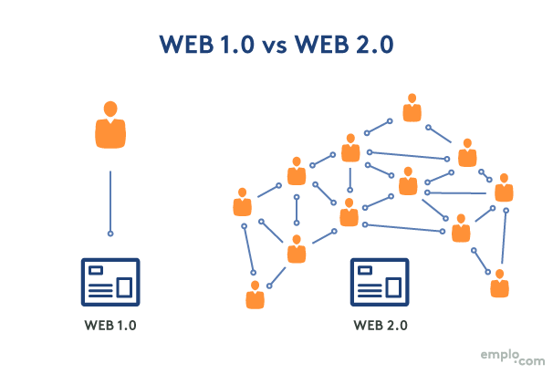

# References

* <https://www.google.com/search?q=outline+the+web+architecture+and+components+which+enable+internet+and+web+functionality+flowchart&tbm=isch&ved=2ahUKEwjw9qf2hLLsAhUSixoKHfInBPAQ2-cCegQIABAA&oq=outline+the+web+architecture+and+components+which+enable+internet+and+web+functionality+flowchart&gs_lcp=CgNpbWcQA1C4aliffWDLgAFoAHAAeACAAYkBiAHsBZIBAzkuMZgBAKABAaoBC2d3cy13aXotaW1nwAEB&sclient=img&ei=btyFX_CHMpKWavLPkIAP&bih=754&biw=1536&rlz=1C1CHBF_en-GBGB919GB919#imgrc=pkz6hhUJ756nXM>
* <https://webarc.weebly.com/current-methods-of-information-sharing-m1.html>
* <https://developer.mozilla.org/en-US/docs/Learn/Common_questions/What_is_a_web_server>
* [https://searchunifiedcommunications.techtarget.com/definition/Internet-Protocol#:~:text=The%20Internet%20Protocol%20(IP)%20is,other%20computers%20on%20the%20Internet.&text=The%20Internet%20Protocol%20just%20delivers%20them.](https://searchunifiedcommunications.techtarget.com/definition/Internet-Protocol%23:~:text=The%20Internet%20Protocol%20(IP)%20is,other%20computers%20on%20the%20Internet.&text=The%20Internet%20Protocol%20just%20delivers%20them.)